Installation Guide
V 0.7

Cancer Adverse Event Reporting System (caAERS)
SemanticBits, LLC

Document Change History
Version Number | Date | Contributor | Description
Prior Drafts |  |  | Prior drafts
V. 0.2 | April 2007 |  | Draft for installing Iteration 2 (March 07). In the previous iteration, the data source configuration was included in the war file, which required adopters to build caAERS locally. In this iteration, we have moved the data source configuration out of the war file so that you will no longer need to build caAERS, going forward.
V. 0.5 | February 2007 | Krikor Krumlian | Initial Draft
V.0.6 | May 2007 | Biju Joseph | Second Draft , maven related changes, some manual steps introduced
V. 0.6.1 | May 2007 | Biju Joseph | Incorporated the changes based on Srinivasa Akkal.
V. 0.7 | July 2007 |  | Updated content, including software version. Removed build software installation (Maven, Eclipse, ANT).

caBIG™ is an initiative of the National Cancer Institute, NIH, DHHS

Table of Contents

Introduction 1
Overview of caAERS 1
Client 1
Tomcat 1
caaers.war 1
PostgreSQL/Oracle 1
Minimal System Requirements 2
Minimal Client System Requirements 2
Server Software and Technology Requirements 2
Software Requirements 2
Required Software 2
Database Requirements 3
Database Software 3
Installation 3
Preliminary Considerations 3
1.0 Preliminaries 4
1.1 Installing JDK 4
1.2 Installing Tomcat 4
1.3 Installing an SVN Client 4
1.4 Downloading the Latest Source Code 4
1.5 Download the Latest Compiled .war file 4
2.0 Installing and Configuring the Database 5
2.1 Installing the Database 5
2.2 Configuring the Database for Use with caAERs 5
3.0 Configuring Tomcat 6
4.0 Enabling SSL 7
4.1 Generate a Certificate 7
4.2 Updating the server.xml 7
5.0 Loading the Database with the Schema/Deploying the caAERS.war 8
Contacting Technical Support 8
Application Support 8

Introduction
This installation guide outlines the supported configurations and instructions for installing, setting up, and configuring the Cancer Adverse Event Reporting System (caAERS) application.

Overview of caAERS | The caAERS application is an open source, standards-compliant software application that can be used by organizations that manage patients on cancer clinical trials. caAERS is a standalone, web-based application that allows users to enter SAE and AE reports.

caAERS Deployment:

Client
PostgreSQL/
Oracle

caaers.war

Tomcat

Diagram 1 caAERS Deployment

Client | Web browser, preferably Internet Explorer 6 or Firefox 1.5
Tomcat | Web server and servlet container, Apache Tomcat 5.5.17
caaers.war | Contains the files of the caAERS application
PostgreSQL/Oracle | Database to support caAERS, PostgreSQL 8.x or Oracle 10g

Minimal System Requirements

Minimal Client System Requirements | - Internet connection  - Firefox 1.5 or higher or Internet Explorer 6

The caAERS server has been tested on the platforms shown in Table 1.
 | Macintosh | Windows
Model | Xserve G4 | Dell Dimension 8200
CPU | 2 x 1 GHz PowerPC G4 | 1 x Intel® Pentium™ Processor 1.80GHz
Memory | 2 GB | 1 GB
Local Disk | System 2 x 180 GB | System 1 x 36GB
OS | OSX 10.4 | Windows XP
Table 1 Platform Testing Environment

Server Software and Technology Requirements

Software Requirements
Required Software | You must download and install a set of required software that is not included with the caAERS application software bundle. The software name, version, description, and URL hyperlinks (for download) are listed below in Table 2.

Required Software:
Software Name | Version | Description | URL
Java SE Development Kit | JDK 5.0 or higher | The Java SE development kit with JRE, compilers and debuggers | http://java.sun.com/javase/downloads/index.jsp
Apache Tomcat | 5.5.23 or higher | Servlet container for JSP | http://tomcat.apache.org/download-55.cgi
Table 2 Required software and technology

Database Requirements

Database Software | The caAERS application requires access to a properly-configured database. JDBC drivers for HSQLDB and PostgreSQL have been included. If your site is using an Oracle database, you will need to obtain the necessary Oracle drivers and place them in the db/lib directory. caAERS is built with database-independence in mind and has been tested on the following:

Database Name | Version | Description | URL
PostgreSQL | 8.1.9 or higher | PostgreSQL is a powerful, open source relational database system. | http://www.postgresql.org/download/
Oracle | 10g Release 2 or higher | Industry-leading, commercial database product. | http://www.oracle.com/technology/software/products/database/oracle10g
Table 3 Database software

Installation

Preliminary Considerations
BEFORE YOU BEGIN | caAERS has been tested with the operating systems and hardware specified on page 1 of this guide. Although we have made an effort to develop caAERS as a platform-independent application, we cannot guarantee that it will work if you are using variations of these operating systems and/or hardware. Although installing caAERS on a system already setup with the proper versions of the JDK, database, and Tomcat should require only about 30 minutes, installation from scratch could take several hours.

1.0 Preliminaries
This section describes the preliminary steps required to establish an environment required to successfully run the caAERS application.
1.1 Installing JDK
Download and install Java Standard Edition 5.0 or higher from (http://java.sun.com/javase/downloads/index.jsp). Make sure that directory name where you install java or the parent directories do not contain a white space in between. Throughout this guide the java installation directory will be referred as ${java.dir}.

Add the ${java.dir}\bin to your system PATH. Also set a new environment variable named JAVA_HOME, whose value must = ${java.dir}
1.2 Installing Tomcat
Download the Apache Tomcat version 5.5.23 or higher from http://tomcat.apache.org/download-55.cgi. Install the tomcat application in a convenient location. Throughout this guide the tomcat installation directory will be referred as ${tomcat.dir}. Add a new environment variable CATALINA_HOME, whose value must = ${tomcat.dir}
1.3 Installing an SVN Client
To checkout the latest code, you need to have a Subversion (SVN) client installed on your system. Install the Subversion client provided below.

Windows
- Standalone:
http://tortoisesvn.tigris.org/

Mac
- Standalone:
http://www.apple.com/downloads/macosx/development_tools/svnx.html

1.4 Downloading the Latest Source Code
Once the SVN client is installed create a directory in a convenient location to checkout the caAERS source code. Throughout this guide the source code directory will be referred as ${workspace}.

Right click ${workspace}, select SVN Checkout and enter the following repository URL:
https://gforge.nci.nih.gov/svnroot/caaersappdev/trunk/

1.5 Download the Latest Compiled .war file
Proceed to the caAERS Subversion repository at http://gforge.nci.nih.gov/frs/?group_id=249. Use this URL to download the latest compiled .war file caaers-20070412.zip from the caAERS project site. Unzip the file contents into a convenient location, this directory will be referred as ${caAERS}.

2.0 Installing and Configuring the Database
caAERS supports two databases, Oracle and PostgreSQL. To successfully deploy caAERS you need to have one of these databases installed on your system.

Note: The instructions for installing an Oracle or Postgres database are beyond the scope of this document. Refer to the installation documents that accompany these databases for step-by-step instructions.

2.1 Installing the Database
Complete the following steps to prepare the database for caAERS:

- Install the preferred database product (PostgreSQL 8.1.9 or Oracle 10g)
- Create an empty database for caAERS to use. You may give your database any valid name, but this guide will use “caaers” as the name in each example.
- Create a schema named “caaers” in the database.
- Create a superuser with privileges to access the database created above.

Note: There is a readme.database in \caaers\projects\core that provides more details on how to do the configuration with postgres and oracle databases.

2.2 Configuring the Database for Use with caAERS
The following directions will explain how to set this up in etc/caaers directory, for postgres database.

- Create the directory: c:\etc and a subfolder\caaers
- Go to ${workspace}\caaers\projects\rules\db
  - To configure the database, copy the file "caaers.properties.sample", into c:\etc\caaers\ and rename the file "datasource.properties". Then, edit datasource.properties attributes to match the “caaers” database.
    - Set `datasource.url` to the JDBC URL for your database
    - Set the username and password to use to access this URL
    - Uncomment the database configuration block that corresponds to your database type

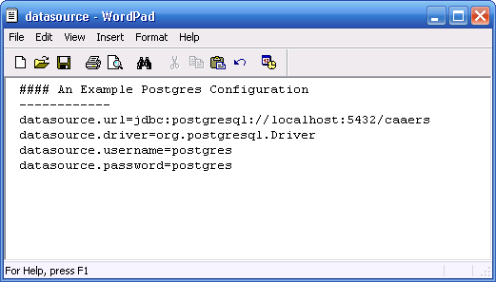

3.0 Configuring Tomcat
- Add the following lines in ${tomcat.dir}/conf/catalina.properties

gov.nih.nci.security.configFile= ${tomcat.dir}/conf/cabig/ApplicationSecurityConfig.xml
java.security.auth.login.config= ${tomcat.dir}/conf/cabig/csm_jaas.config

- To manually install these configuration files:
  - Create a new folder: ${tomcat.dir}/conf/cabig
  - Copy all the files in ${workspace}/projects/core/tools/csm/conf/cabig to ${tomcat.dir}/conf/cabig

    - Open ApplicationSecurityConfig.xml and caaers.hibernate.cfg.xml in a text editor and replace the following:
    - @csm.context.name@ to caaers
    - @tomcat.security.dir@ to ${tomcat.dir}/conf/cabig

- Open the csm_jaas.config and change the following fields:
  - Driver
  - url
  - user
  - psswd
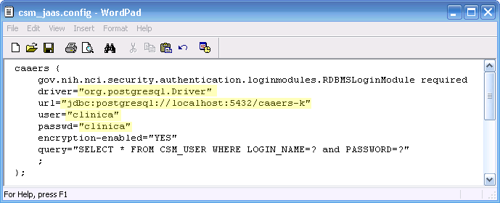

- Open caaers.hibernate.cfg.xml and change the following datasource related properties
  - Username
  - Password
  - URL
  - Driver Class
  - Dialect

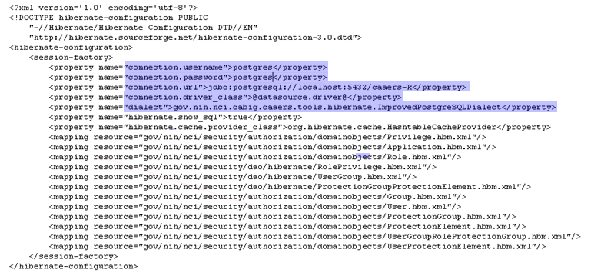

4.0 Enabling SSL
Please refer to the detailed instructions available in http://tomcat.apache.org/tomcat-5.0-doc/ssl-howto.html, to enable SSL.
4.1 Generate a Certificate
- From the command prompt switch to ${tomcat.dir}/conf/cabig, then run the following command
keytool -genkey -alias tomcat -keyalg RSA -keystore caaers_keystore. This will generate a file, “caaers_keystore” in the active directory.

- The keytool command will request the following information, please complete each field
  - Store password
  - Firstname
  - Last name
  - Dns
  - Key password

4.2 Updating the server.xml
- Switch to ${tomcat.dir}/conf, open the server.xml in a text editor
- Search for the lines “<!-- Define a SSL Coyote HTTP/1.1 Connector on port 8443 -->”
- Update the <Connector> element, by un commenting it and specifying the relative directory of the keystore.

<!-- Define a SSL Coyote HTTP/1.1 Connector on port 8443 -->
<Connector className="org.apache.coyote.tomcat5.CoyoteConnector"
port="8443" minProcessors="5" maxProcessors="75"
enableLookups="true" disableUploadTimeout="true"
acceptCount="100" debug="0" scheme="https" secure="true";
clientAuth="false" sslProtocol="TLS"
keystoreFile="conf/cabig/caaers_keystore"/>

5.0 Loading the Database with the Schema/Deploying the caAERS.war
- Copy the caaers.war file from the directory ${caAEERS}
- Start tomcat, by executing the startup.bat or startup.sh file located in ${tomcat.dir}/bin
- Starting tomcat will automatically deploy the caaers.war file, this will create a /caeers directory within ${tomcat.dir}/webapps and load the schema into the caaers database
- Open a Browser and navigate to http://localhost:8080/caaers/
- The test login name is “SYSTEM_ADMIN” and password is “system_admin”.

Contacting Technical Support
Application Support | Please direct any concerns to the Project Manager of the caAERS Development team, Edmond Mulaire.

